11.

12

14.

16.

18.

Pass function as Props

19.

LifeCycle Methods intro

20.

21

22.

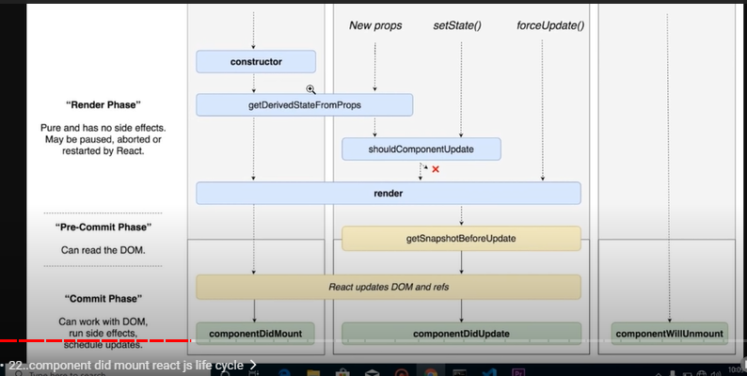

23.

24

25

Mount of parent and child

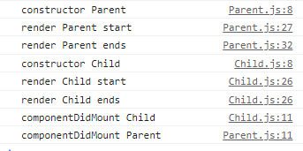

Update of parent and child

26.

27.

28

29

3 types

30.

https://react-bootstrap.github.io/getting-started/introduction

31.

For loop or any other kind of loop not supported inside return statement in react that’s why use map function

32

33.

34

Same as using same Component many times in Parent COmponent

35.

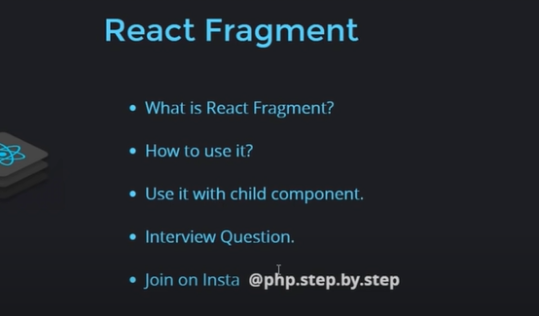

36 lifting state up === data child to parent

Parent :-

Child:

37.

